|  |
| --- |
| **Medicare ( Capstone Project)** |

**Version History:**

|  |  |
| --- | --- |
| Author | Hajaeba Kemal |
| Purpose | Screenshots of the application |
| Date | 17th December 2022 |
| Version | 1.0 |

Table of Contents

1. medicine Page 3

2. Register Page 4

3. Search Medicine Page 6

4. After Search Page 7

# medicine Page

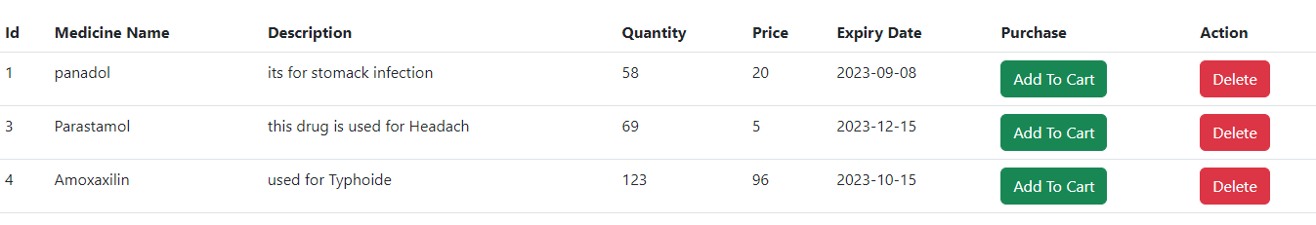

# Register Page

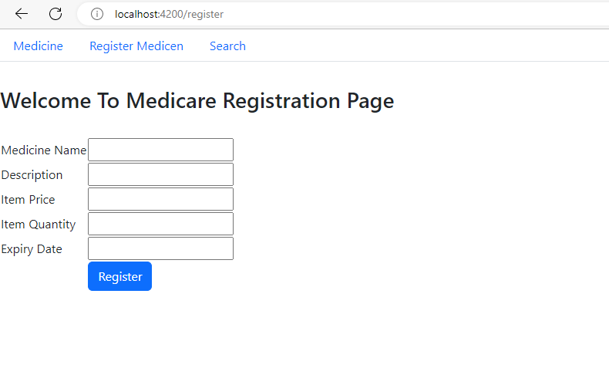

# Search Medicine Page

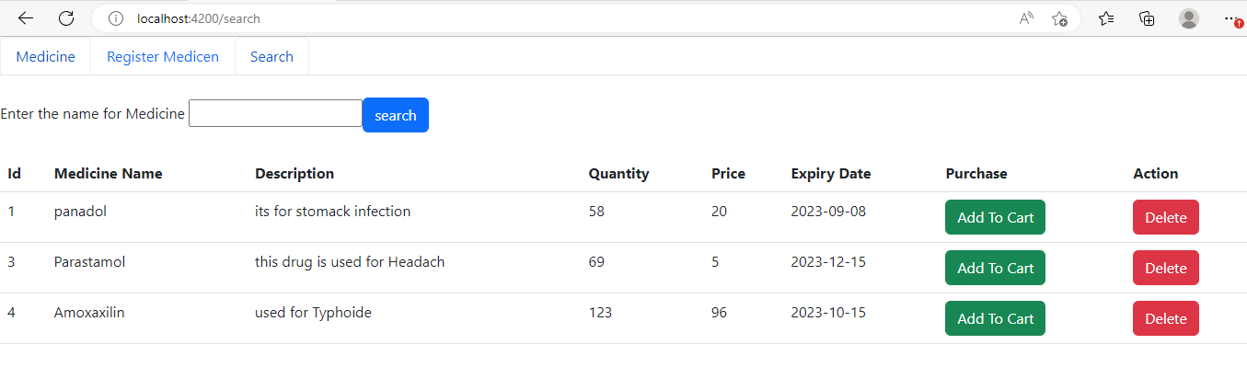

# After Search Page

